Initial Housing Enquiry Form – please return to 12 Lansdowne Walk, W11 3LN or by email to jenny@sheppardtrust.org

Full name ………………………………………………………………………………………….

Address ………………………………………………………………………………………….

………………………………………………………………………………………….

…………………………….Post Code…………………………………………..

Date of Birth ………………………………………………………………………………………….

Telephone Home……………………………..Mobile……………………………………..

Email ………………………………………………………………………………………….

My preferred method of contact is: email □ phone □ post □

Our criteria: The Sheppard Trust provides housing for older women who:
- are aged 65 years or older
- are in need, hardship or distress (for example, low income, low capital resources, qualifying for benefits, insecure/poor housing, not able to find/afford suitable housing. We will not normally consider applicants who own property or have more than £75,000 in capital)
- abide by a Christian faith, with preference being given to those of the Church of England or of some church in communion with the Church of England or some non-conformist denomination.

To help us see how you might meet our criteria, please tell us a little bit about your current circumstances and why you are seeking accommodation at The Sheppard Trust. We will ask for more detailed information if your enquiry proceeds to a full application.

Please tell us how you heard about the Sheppard Trust:

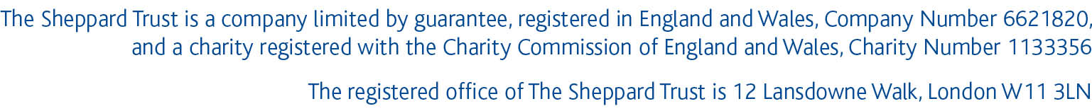
How we use your information: We ask the questions on this form in order to carry out a preliminary assessment of whether you are likely to meet the Trust’s criteria and to contact you about your enquiry. We will keep your information secure, and we will not use it for any other reason or share it with anyone else. If we are not able to take your enquiry further we will destroy your information within 6 months. If you would like more information about this, please email jenny@sheppardtrust.org or phone 020 7727 5500.

